DAA – LAB EXPERIMENTS
P.Sai Swetha
192324011
01-10-2026

Exp 1:
CODE:
def first_palindrome(words):
for word in words:
if word==word[::-1]:
return word
return""
words=["abc","car","ada","racecar","cool"]
print(first_palindrome(words))

OUTPUT:

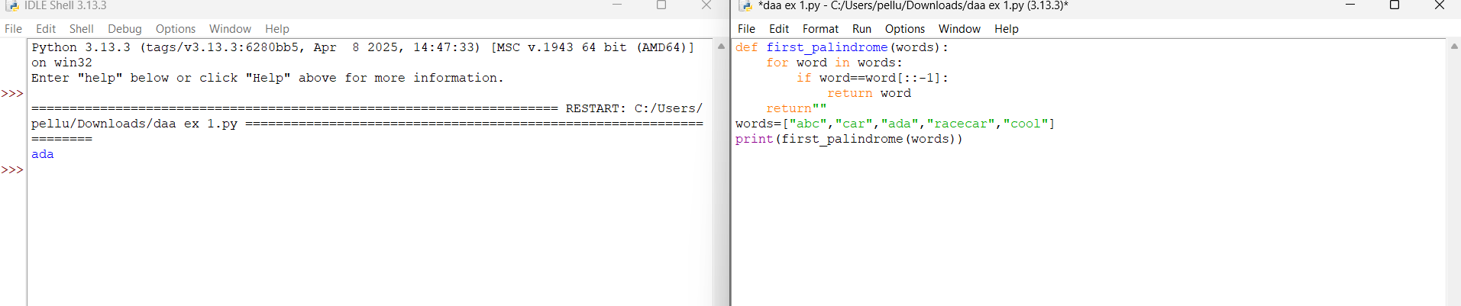

EXP 2:
CODE:
def find_difference(nums1,nums2):
answer1=0
answer2=0
for x in nums1:
if x in nums2:
answer1+=1
for x in nums2:
if x in nums1:
answer2+=1
return [answer1,answer2]
nums1=[2,3,2]
nums2=[1,2]
print(find_difference(nums1,nums2))

OUTPUT:

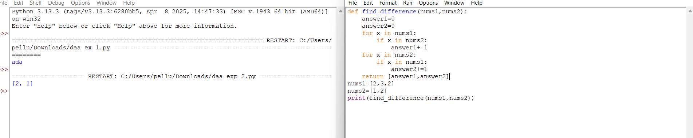

EXP 3 :
CODE:
def sum_counts(nums):
total=0
n=len(nums)
for i in range(n):
s=set()
for j in range(i,n):
s.add(nums[j])
count=len(s)
total+=count*count
return total

nums=[1,2,1]
print(sum_counts(nums))

OUTPUT:

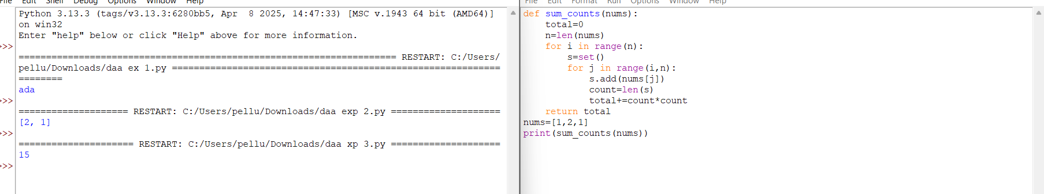

EXP 4 :
CODE:
def count_pairs(nums,k):
count=0
n=len(nums)
for i in range(n):
for j in range(i+1,n):
if nums[i]==nums[j] and (i*j)%k==0:
count+=1
return count
nums=[3,1,2,2,2,1,3]
k=2
print(count_pairs(nums,k))

OUTPUT:

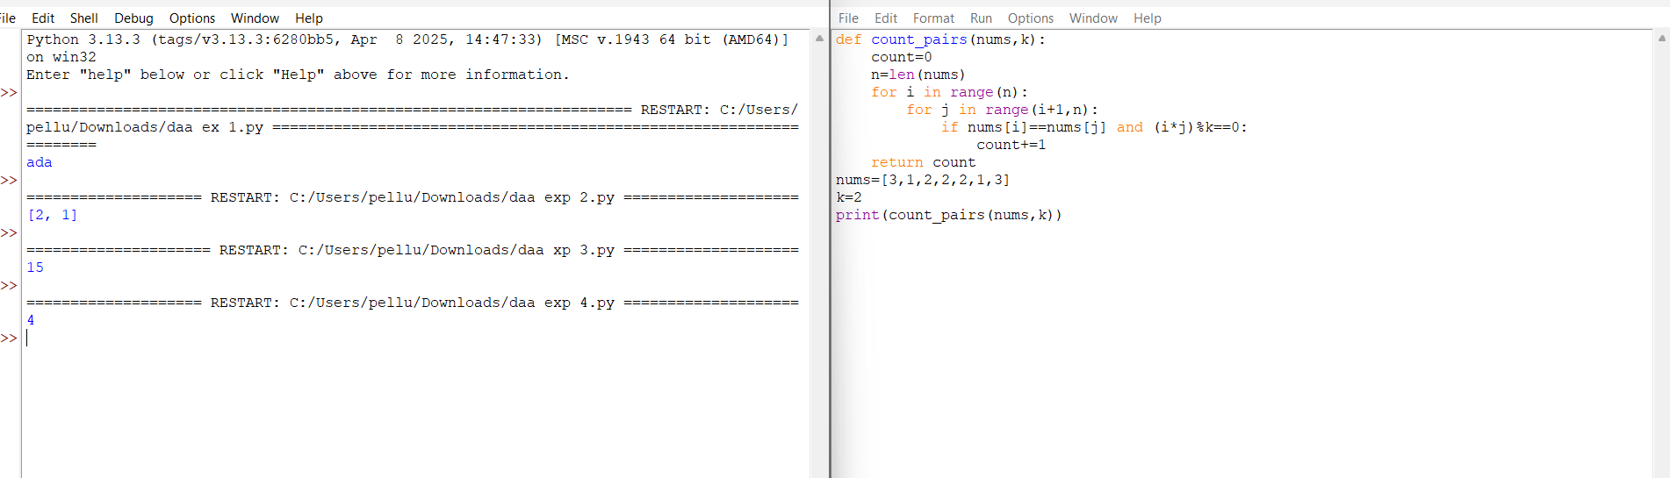

EXP 5:
CODE:
def find_max(nums):
maximum=nums[0]
for x in nums:
if x>maximum:
maximum=x
return maximum
print(find_max([1,2,3,4,5]))
print(find_max([7,7,7,7,7]))
print(find_max([-10,2,3,-4,5]))

OUTPUT:

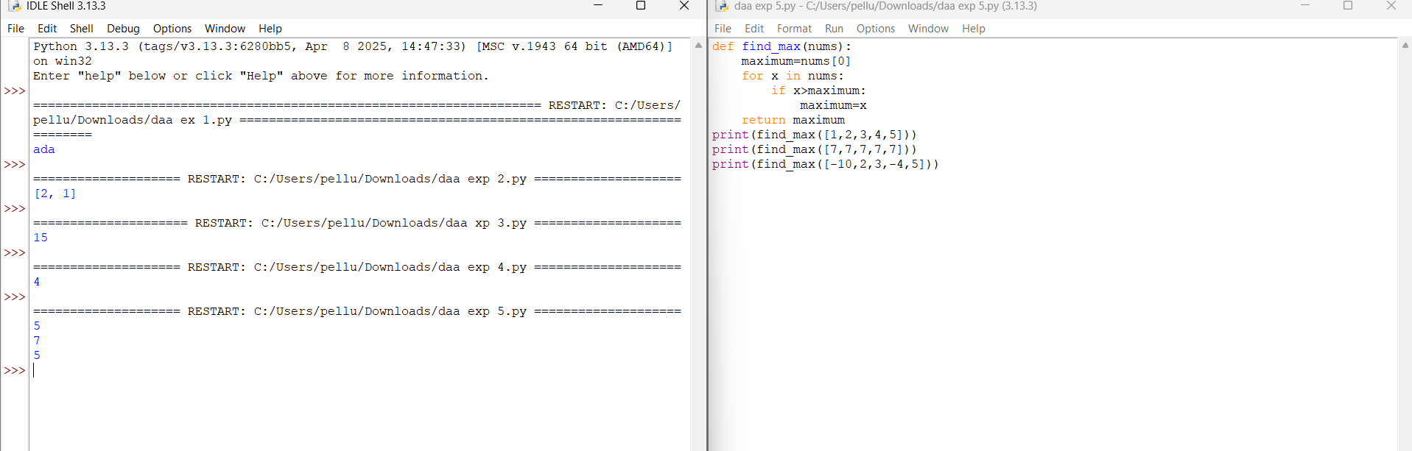

EXP 6:
CODE:
def find_max(nums):
if len(nums)==0:
return None
nums.sort()
return nums[-1]
print(find_max([]))
print(find_max([5]))
print(find_max([3,3,3,3,3]))

OUTPUT:

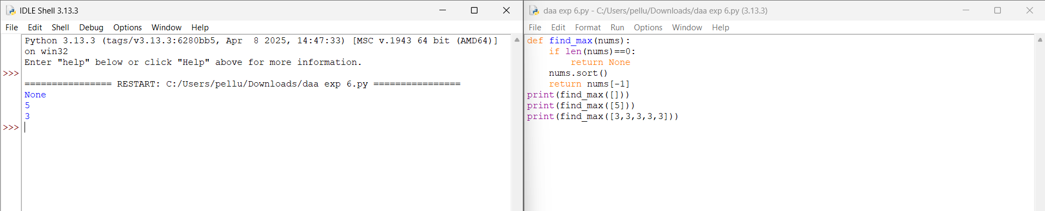

EXP 7:
CODE:
def unique_elements(nums):
return list(set(nums))
print(unique_elements([3,7,3,5,2,5,9,2]))
print(unique_elements([-1,2,-1,3,2,-2]))
print(unique_elements([1000000,999999,1000000]))

OUTPUT:

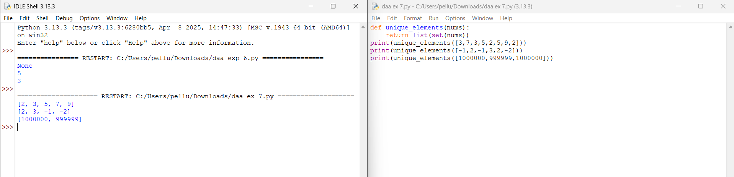

EXP 8:
CODE:
def bubble_sort(arr):
n=len(arr)
for i in range(n):
for j in range(0,n-i-1):
if arr[j]>arr[j+1]:
arr[j],arr[j+1]=arr[j+1],arr[j]
return arr
arr=[5,3,8,1,2]
print(bubble_sort(arr))

OUTPUT:

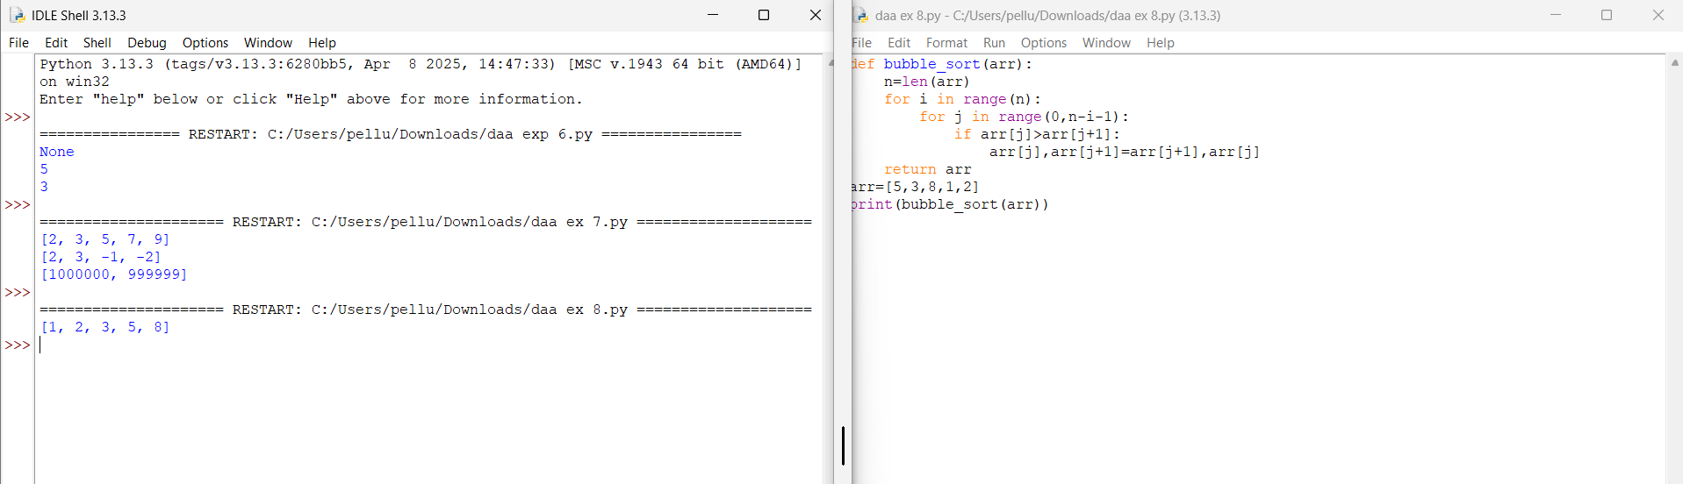

Exp 9:
CODE:
def binary_search(arr,key):
arr.sort()
low=0
high=len(arr)-1

while low<=high:
mid=(low+high)//2

if arr[mid]==key:
return mid+1
elif arr[mid]<key:
low=mid+1
else:
high=mid-1

return -1
arr=[3,4,6,-9,10,8,9,30]
key=10
pos=binary_search(arr,key)
if pos!=-1:
print("Element",key,"is found at position",pos)
else:
print("Element",key,"is not found")

OUTPUT:

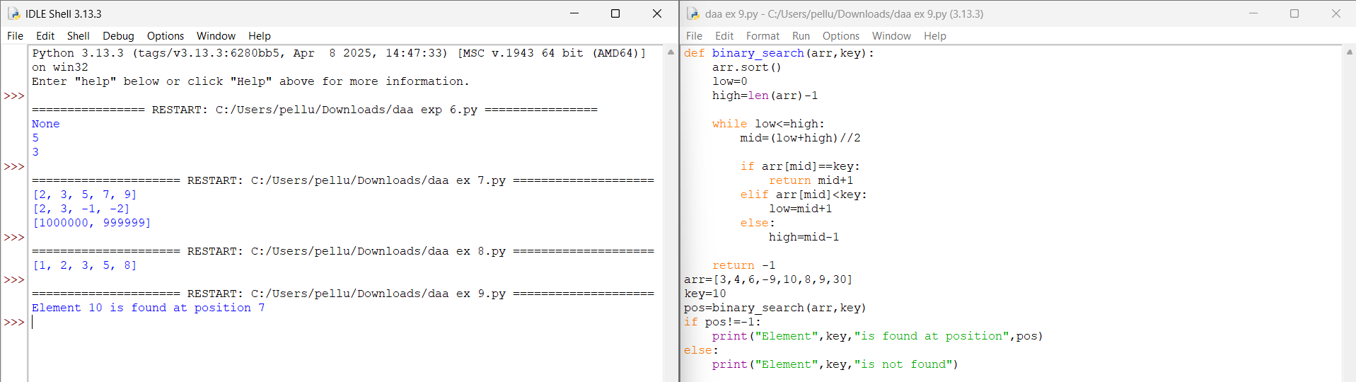

Exp 10 :
CODE:
def merge_sort(arr):
if len(arr)<=1:
return arr

mid=len(arr)//2
left=merge_sort(arr[:mid])
right=merge_sort(arr[mid:])

result=[]
i=0
j=0

while i<len(left) and j<len(right):
if left[i]<=right[j]:
result.append(left[i])
i+=1
else:
result.append(right[j])
j+=1

result.extend(left[i:])
result.extend(right[j:])

return result

nums=[5,2,3,1,4]
print(merge_sort(nums))

OUTPUT:
